**Assignment 1**

Introduction to Dataset

* A team has performed several experiments to test the efficiency of video streaming methods. For better validation of results, tests are conducted using four network conditions/profiles with seven video samples under three buffer capacity configurations.
* In the first configuration, the total duration of video that can be stored in the buffer is either 30 seconds or 60 seconds based on the duration of the video. If the video is more than 10 minutes, the buffer capacity is 60 seconds, else, it is 30 seconds.
* In the other two configurations, the buffer capacity is fixed and not dependent on video duration, i.e., 120 seconds and 240 seconds.
* Video sample V1, V4, and V5 are less than 10 minutes and remaining (V2, V3, V6, and V7) are more than 10 minutes. The results are stored in **result.csv** file.
* The result csv file has following attributes **<profile, sample, method, quality, change, inefficiency, stall, numStall, avgStall, overflow, numOverflow, qoe, bufSize>.** The definitions for the attributes are:
* **profile**: Network profile used for testing.
* **sample**: Video sample on which test is conducted.
* **method**: Method used for streaming.
* **quality**: Average quality played (in Kbps).
* **change**: Changes in quality during the playback.
* **inefficiency**: Inefficiency of the method to fully utilize the available bandwidth.
* **stall**: Total stall duration (in seconds) during the playback.
* **numStall**: Number of stalls happened during the playback.
* **avgStall**: Average stall duration (in seconds) during the playback.
* **overflow**: The duration (in seconds) for which buffer was full.
* **numOverflow**: Number of times when buffer was full.
* **qoe**: Quality of experience during the playback.
* **bufSize**: Maximum content that can be buffered/ buffer capacity (in seconds).

Your Task:

Based on the description given above, plot the visualization for following queries. Feel free to use your choice of plot (bar plot, histogram, stacked plot, X-Y plot, etc.) to clearly visualize the results:

1. Draw a plot depicting the superiority of a method in terms of Average quality and number of changes in the quality (average value for all video samples and network profile). Each buffer configuration should have a separate single plot.
2. Draw a single plot for all buffer configurations showing QoE (average value for all video samples and network profile) for all methods. You are expected to show the comparison of the QoE of a method in all buffer configurations as well as the comparison of all methods using the single plot.
3. Draw plots to show the correlation between inefficiency and quality for all methods in all buffer configurations.
4. We would like to know the methods which have the minimum number of stalls for video V7 under all network profiles. Draw appropriate plot for it.

Expectations:

* To choose appropriate plot that clearly depict the required information.

* Use Python or R as per your convenience.
* Feel free to contact us in case of any doubt at cs5346.tutor@gmail.com.

Grading:

Assignment 1 is worth 5% of your final grade. Grading will be based on the following:

1. Type of plot used for visualisation.
2. Clarity of the interpretations from the visualisation plots.

Late submission, incomplete work or missing demonstration could invite penalty.

Submission Deadline: **29 January 10:00 AM**

Submission Instructions:

**For Python:**

* Download and extract the folder uploaded on IVLE.
* Navigate to the project directory using the terminal and enter the command -

jupyter notebook

* This would launch jupyter notebook and redirect the students directly to the browser.
* Select the python notebook assignment_1.ipynb from the directory pane visible in the browser.
* Finally, you will be able to see the workspace where they can write their code.
* You can use Markdown for comments/explanations.
* Write the code in the jupyter notebook and execute it by hitting "Shift + Enter".

* **For submission, rename the python notebook to your matric card number and save it as python notebook ( e.g., A01234567Z.ipynb ) and upload it back to “Student Submission** / **Assignment 1” folder in IVLE.**

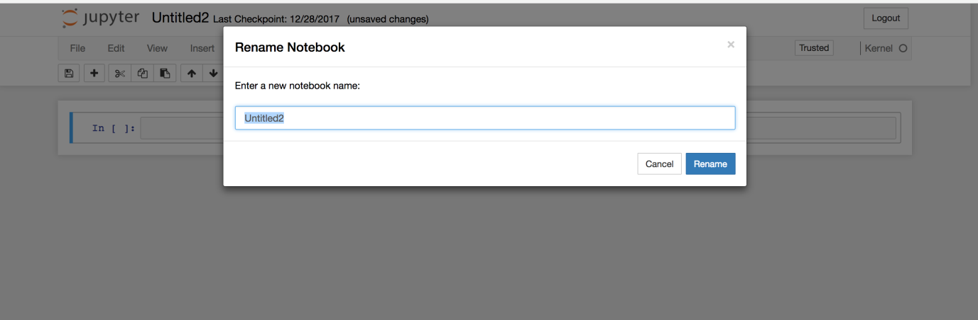

**For R:**

* Use R only if you are already familiar with it, as Lab 1 hands-on document doesn’t contain any guidance for it.
* Create a zip the R script file and plot.
* Use inline comments for explanation if any.
* **Upload the zip file with file name contain the matric card number (e.g., A01234567Z.zip) to “Student Submission / Assignment 1” folder in IVLE.**